LABORATORIYA ISHI -8
Mavzu: PHP orqali fayl yuklash va saqlash moduli
Ishning maqsadi
Talabalar:
- PHP’da fayl yuklashni o‘rganadi
- Faylni serverga saqlashni amalga oshiradi
- Faylni tekshirish (format, hajm)ni bajaradi
- Xavfsiz upload tizimini yaratadi

Nazariy qism
Fayl yuklash qanday ishlaydi?
- Foydalanuvchi fayl tanlaydi
- Forma orqali serverga yuboradi
- PHP faylni $_FILES orqali qabul qiladi
- Fayl vaqtinchalik papkaga tushadi
- move_uploaded_file() orqali kerakli papkaga ko‘chiriladi

$_FILES haqida
$_FILES['file']
Elementlari:
- name – fayl nomi
- tmp_name – vaqtinchalik joylashuv
- size – hajmi
- type – turi
- error – xatolik

1-qadam: Oddiy fayl yuklash
index.php (forma)
<!DOCTYPE html>
<html>
<head>
<title>Fayl yuklash</title>
</head>
<body>
<form action="upload.php" method="post" enctype="multipart/form-data">
Fayl tanlang:
<input type="file" name="file">
<button type="submit">Yuklash</button>
</form>
</body>
</html>

upload.php (server qismi)
<?php
$target_dir = "uploads/";
$file_name = $_FILES["file"]["name"];
$tmp_name = $_FILES["file"]["tmp_name"];
move_uploaded_file($tmp_name, $target_dir . $file_name);
echo "Fayl yuklandi!";
?>

Papka tuzilishi
project/
│
├── index.php
├── upload.php
└── uploads/

2-qadam: Xavfsiz upload
Fayl turini tekshirish
<?php
$allowed = ['jpg', 'png', 'pdf'];
$file_name = $_FILES["file"]["name"];
$ext = strtolower(pathinfo($file_name, PATHINFO_EXTENSION));
if(!in_array($ext, $allowed)){
echo "Faqat JPG, PNG, PDF fayllar ruxsat etiladi!";
exit;
}
?>

Fayl hajmini tekshirish
<?php
$max_size = 2 * 1024 * 1024;
if($_FILES["file"]["size"] > $max_size){
echo "Fayl hajmi juda katta!";
exit;
}
?>

To‘liq xavfsiz uploadkodi
<?php
$target_dir = "uploads/";
$file_name = $_FILES["file"]["name"];
$tmp_name = $_FILES["file"]["tmp_name"];
$file_size = $_FILES["file"]["size"];
$allowed = ['jpg', 'png', 'pdf'];
$ext = strtolower(pathinfo($file_name, PATHINFO_EXTENSION));
if(!in_array($ext, $allowed)){
die("Noto‘g‘ri fayl turi!");
}
if($file_size > 2 * 1024 * 1024){
die("Fayl 2MB dan katta!");
}
$new_name = time() . "_" . $file_name;
if(move_uploaded_file($tmp_name, $target_dir . $new_name)){
echo "Fayl muvaffaqiyatli yuklandi!";
} else {
echo "Xatolik yuz berdi!";
}
?>

3-qadam: Ko‘p fayl yuklash
Forma
<form action="upload.php" method="post" enctype="multipart/form-data">
<input type="file" name="files[]" multiple>
<button type="submit">Yuklash</button>
</form>

PHP kodi
<?php
foreach($_FILES['files']['tmp_name'] as $key => $tmp_name){
$name = $_FILES['files']['name'][$key];
$tmp = $_FILES['files']['tmp_name'][$key];
move_uploaded_file($tmp, "uploads/" . $name);
}
echo "Barcha fayllar yuklandi!";
?>

4-qadam: Rasmni ko‘rsatish
<?php
$files = scandir("uploads/");
foreach($files as $file){
if($file != "." && $file != ".."){
echo "<img src='uploads/$file' width='150'><br>";
}
}
?>

5-qadam: Faylni o‘chirish
<?php
$file = $_GET['file'];
if(file_exists("uploads/" . $file)){
unlink("uploads/" . $file);
echo "Fayl o‘chirildi!";
}
?>

Qo‘shimcha funksiyalar
Papka yaratish
if(!is_dir("uploads")){
mkdir("uploads");
}

Fayl mavjudligini tekshirish
if(file_exists("uploads/" . $file_name)){
echo "Bu fayl allaqachon mavjud!";
}

Umumiy talablar
- enctype="multipart/form-data" majburiy
- Fayl turini tekshirish kerak
- Fayl hajmini cheklash kerak
Topshirqlar:
7-topshiriq
- Rasm yuklash
- Rasmni uploads-FIO/ ga saqlash
- Rasmni sahifada ko‘rsatish
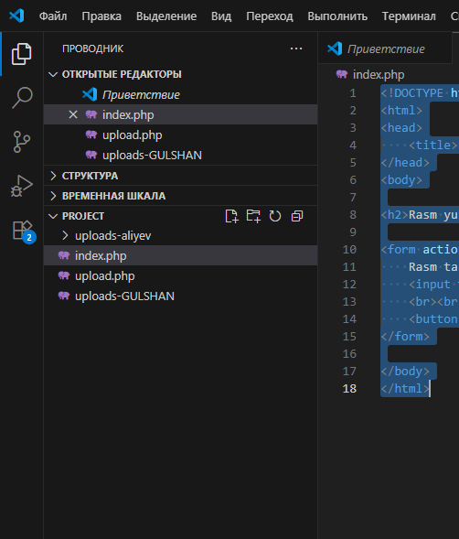
KOD
index.php
<!DOCTYPE html>
<html>
<head>
<title>Rasm yuklash</title>
</head>
<body>

<h2>Rasm yuklash</h2>

<form action="upload.php" method="post" enctype="multipart/form-data">
Rasm tanlang:
<input type="file" name="image" required>
<br><br>
<button type="submit">Yuklash</button>
</form>

</body>
</html>
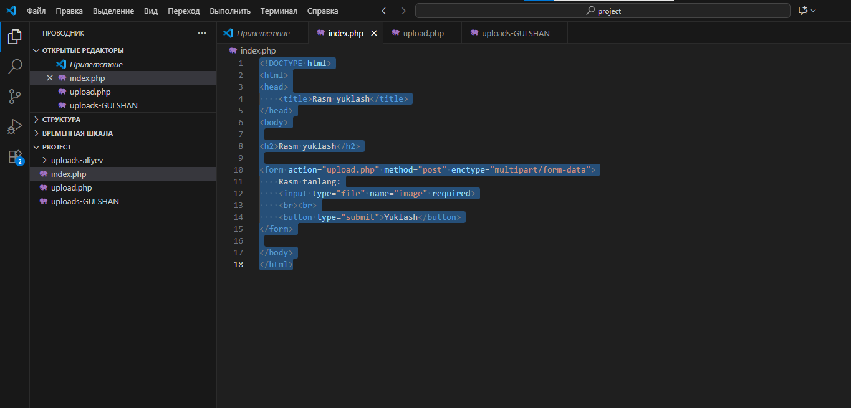
upload.php
<?php

$target_dir = "uploads-aliyev/"; // o‘zingizni FIO yozing

// Agar papka mavjud bo‘lmasa yaratiladi
if(!is_dir($target_dir)){
mkdir($target_dir);
}

$file_name = $_FILES["image"]["name"];
$tmp_name = $_FILES["image"]["tmp_name"];
$file_size = $_FILES["image"]["size"];

// Fayl turi
$allowed = ['jpg', 'jpeg', 'png'];
$ext = strtolower(pathinfo($file_name, PATHINFO_EXTENSION));

// 1️⃣ Format tekshirish
if(!in_array($ext, $allowed)){
die("Faqat JPG, JPEG, PNG rasm yuklash mumkin!");
}

// 2️⃣ Hajm tekshirish (2MB)
if($file_size > 2 * 1024 * 1024){
die("Rasm hajmi 2MB dan katta!");
}

// 3️⃣ Yangi nom berish
$new_name = time() . "_" . $file_name;

// 4️⃣ Yuklash
if(move_uploaded_file($tmp_name, $target_dir . $new_name)){
echo "Rasm muvaffaqiyatli yuklandi!<br>";
echo "<img src='$target_dir$new_name' width='200'>";
} else {
echo "Xatolik yuz berdi!";
}

?>
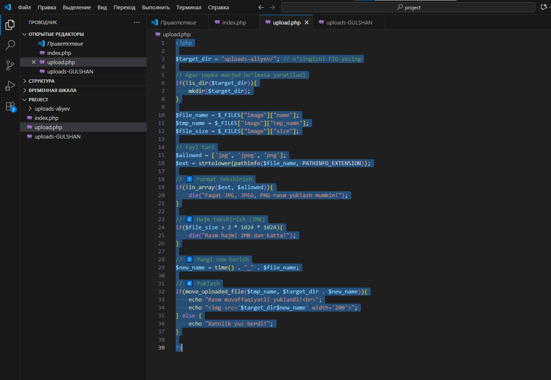
uploads-FIO/GULSHAN
<?php

$files = scandir("uploads-GULSHAN/");

foreach($files as $file){
if($file != "." && $file != ".."){
echo "<img src='uploads-GULSHAN/$file' width='150'><br>";
}
}

?>
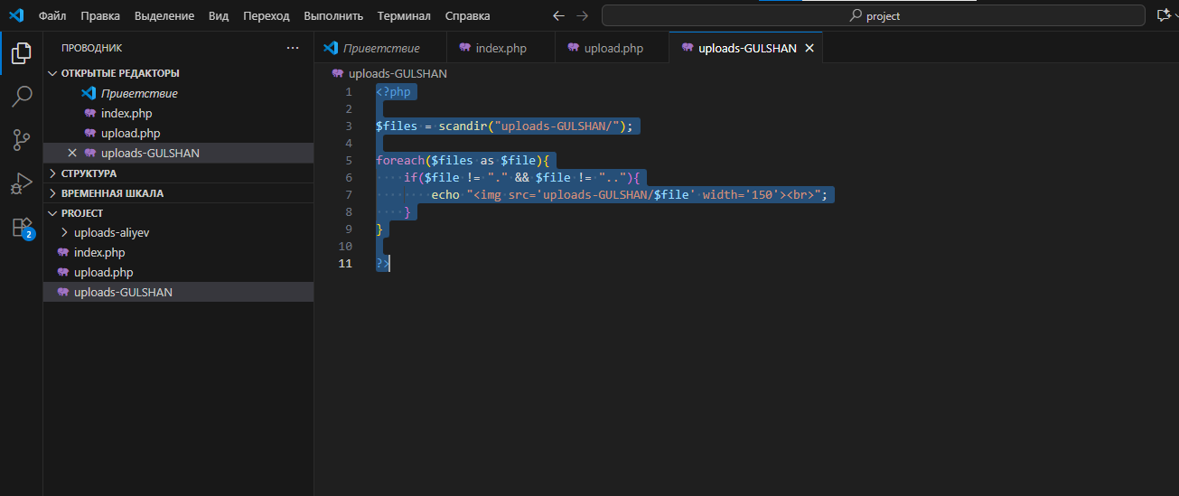
NATIJA
